Rattle Snake Avoidance Clinic

Prado Recreation Dog Park, Chino
Saturday May 13th. Starting at 8:00 A.M.

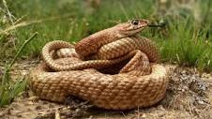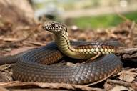

Rattlesnakes are a big problem here in California for dog owners.
Here are two of the ways that your dog can be bitten by a rattle snake:
1. Hunting dogs with their high prey instinct will attack a rattle snake attracted by the movement, the sound or the smell of a snake.
2: A dog running at full speed during hunting/or playing in open space can step on or run by a rattle snake and get bitten.
To avoid this from happening:
1. Train your dog to avoid a rattle snake with Rattle Snake Avoidance Clinic Training.

The SoCal Chapter of the North American Versatile Hunting Dog Association is offering a Rattle Snake Avoidance Clinic at Prado Recreation Dog Park in Chino on Saturday, May 13th starting at 08:00 a.m.

The cost for the clinic is $70 per dog. There is a $15.00 entry fee to the park. Members and, non-members are welcome to sign up for this clinic. Your dog does not have to be a hunting dog to benefit from this training. Any dog exposed to open space where there could be snakes present will benefit.

Please sign up by going to socalnavhda.org. Under the tab “Training and Testing” you will find the Rattlesnake Avoidance Clinic. Use PayPal for payment and you will be given an appointment time.

For questions regarding the clinic contact Rodge Fradella (909) 263-5140.

